

|  |  |
| --- | --- |
| Name : Aneel kumar  Id No : BIT-23f-033  Teacher : Aqsa umar  Lab no : 08 |  |

LAB NO 8

|  |  |
| --- | --- |
| TASK 1 |  |
| Write attributes: | Car that represents a car. The class should have the following |

make: the car's make (e.g., "Toyota") model: the car's model (e.g., "Corolla") year: the car's manufacturing year (e.g., 2020) mileage: the number of miles driven by the car.

The class should have the following methods:

init_(self): Constructor to initialize the car's attributes.

display_info(): Displays the car's information (make, model, year, mileage). drive(miles): Increases the mileage by the specified number of miles

main.py Share Output Clear

E Online compiler (inzerprete;-) to run Python online. Car Info;

2 # write python 3 code in this online eoitor and it. Make: Toyota

3- class Car: Model: Corolla

def make. model, year, mileage=0): Year: 2020

# Constructor to car's attributes Mileage: 0 miles

self.make = make The car has been driven for 150 miles. New mileage: 150 miles.

self .model = model Car Info:

self.year = year Make: Toyota

self ,mileage - mileage Model: corolla

Year: 2020

def display_info(self) Mileage: ISO miles

# Displays the car '5

print(f"Car {self. make} \nModel : {self Code Execution Successful --2

{self .year}XnMileage: @self.mileagejl

miles" )

14

det drive(self, miles):

1. # increases the mileage by the specified number of miles self .mileage miles

18 print(f"The car has been driven tor {miles} miles. New mileage: {self .mileage} miles. "

19

20- # Exsmple xe

Task2 .Write the following attributes:

name: the student's name. age: the student's age.

Student that represents a student. The class should have

marks: a list of the student's marks.

The class should have the following methods:

init_(self): Constructor to initialize the student's attributes.



add_marks(self, marks): Adds a list of marks to the student's marks list.

average_marks(self): Calculates and returns the average of the student's marks. display_info(self): Displays the student's information (name, age, average marks)

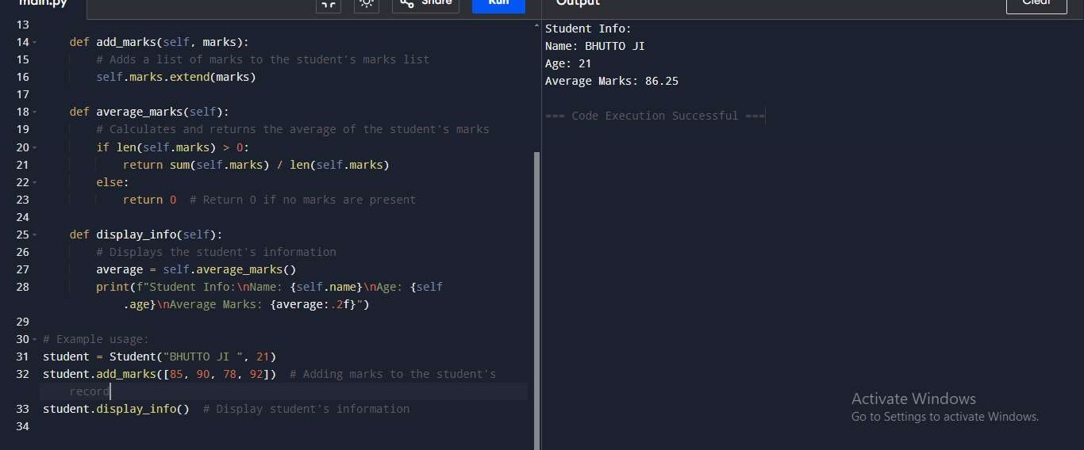

TASK 3 Write BankAccount that represents a bank account. The class should have the following attributes:

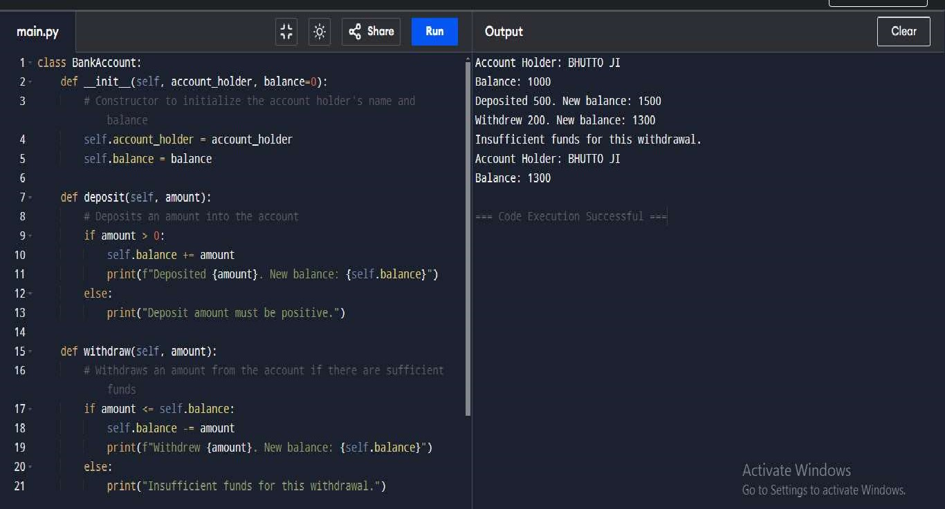account holder: the name of the account holder. balance: the balance of the account.

The class should have the following methods:

init (self): Constructor to initialize the account holder's name and balance. deposit(self, amount): Deposits an amount into the account.

withdraw(self, amount): Withdraws an amount from the account if there are sufficient funds. display_balance(self): Displays the current balance of the account.